Annex No 2.
to the Regulation
for competitive procurement procedure with negotiation No RBR 2022/XX
“Design and design supervision services for the construction of the new line through Kaunas Urban Node”

General terms and the scope of building design in Lithuania

For the procurement “Design and design supervision services for the construction of the new line through Kaunas Urban Node

*The information in this table is provided for informative purposes in order to provide maximum detail about the perspective scope to all Tenderers, and the Tenderer shall note that exact and highly detailed scope of the services shall be established on the basis of the Agreement, including Technical Specification and its annexes.
No. | Title | Description
 | Services being procured | Master Design, Detailed Technical Design, Design Author’s supervision
 | Contract period, deadline of the Activity | Master Design (24 months), Detailed Technical Design (72 months) and Design author’s supervision (96 month or until the full acceptance of construction works)
 | Applicable procurement law | Latvian
 | Contracting authority | RB Rail AS acting for the benefit and on behalf of Implementing Body
 | Contracting party | RB Rail AS acting for the benefit and on behalf of Implementing Body
 | Beneficiary | Ministry of Transport of the Republic of Lithuania
 | Ref. to the Contracting Scheme | 3.1.2. a); 3.2.2.; 3.2.3.; 3.2.7
 | Applicable construction law | Lithuanian
 | Scope
 | General scope of the contract | • Surveys and Investigations;  • Design Proposals;  • Master Design;  • Building Information Model (BIM);  • Public consultations and hearings;  • Design solution alignment with competent authorities;  • Building (construction) permit obtainment;  • Detailed Technical Design;  • Design author’s Supervision.
 | Key milestones of design process | • Inception Report accepted by the Client  • Geodetic and topography survey report and layout accepted by the Client  • Geotechnical Investigation Factual Report accepted by the Client  • Ground Investigation Report accepted by the Client  • Application and obtainment of technical and other conditions from local institutions, competent authorities, and utility/infrastructure owners;  • Design Proposals (including necessary technical surveys and evaluation of alternatives approved) by Client;  • Master Design (lithuanian: “Techninis projektas”) approved by the Client  • Design approved by utility/infrastructure owners;  • Positive conclusion received from a Design Expertise (to be procured separately);  • Design approved by NoBo/AsBo (Nobo/Asbo services contract is separate from this contract);  • Building (construction) permit received from the authorities;  • Detailed Technical Design (lithuanian: “Darbo Projektas”) accepted.
 | Key milestones of design author’s supervision | - Start of the construction works;  - As-built documentation accepted;  - Construction completion act signed;  - AsBo/NoBo inspection report with positive conclusion received (with prior agreement on any restrictions received from Client).
 | Indicative design scope
 | Section | Kaunas Urban Node (approx. combined 58 km of high-speed (up to 249 km/h) railway mainline)  Layout scheme:  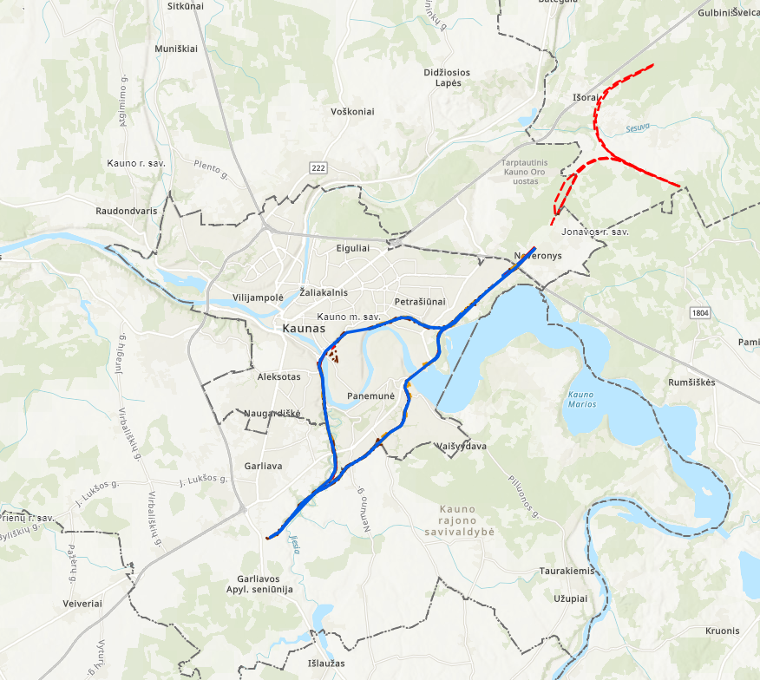
 | Indicative amounts (based on draft EIA studies / spatial planning design) | Kaunas Urban Node (58 km)  Structures:  Number of railway structures: bridges/viaducts: 14 (total ~7km)  Number of retaining wall structures (1.2m): ~3,6 km  Number of road structures bridges/viaducts/pergolas: 10 (total 420m)  Number of pedestrian structures: footbridges/subways/crossings: 550 m  Railway tracks:  1435 mm gauge railway mainline double track: approx. 42 km;  1435mm gauge railway mainline double track connection: approx. 16 km;  Station tracks:  - 1435mm gauge, 8 roads, total length approx.: 3 km;  - 1435mm gauge, 10 roads, total length. approx.: 8 km;  - 1520mm gauge, 4 roads, total length approx.: 1,35 km;  Facilities:  1435 mm gauge railway supporting infrastructure facilities: 5 units;  Number of passing loops: 0 (TBC);  Number of culverts: approx. 4 (TBC);  Number of green bridges: 0 (TBC);  Number of wildlife crossings: approx. 2 (TBC);  Reconstruction 1520 mm gauge existing railway  Other necessary infrastructure elements  Other infrastructure/utilities to be diverted/accommodated along the route:  Local Access Roads  Affected melioration (land reclamation) grid reconstruction;  Main oil and gas pipeline crossings/reconstructions;  High Voltage 110-330 kV power transmission line crossings;  Other utilities (fibre optics, telecoms, low/mid voltage electricity, other).  Note: All the design scope quantities are preliminary and detailed breakdown of the design scope will be provided during the second stage of this procurement.
 | Required contractor’s personnel
 | Key experts: | Design manager;  1435 mm gauge railway track designer;  Structural/bridge designer;
 | Additional experts (non-exhaustive list) | Project manager;  Road design expert/engineer;  Geotechnical expert/engineer;  Environment expert/engineer;  Hydrology expert/engineer;  Building Information Modelling (BIM) Manager.  Project Planning Manager;  Local Stakeholder Manager;  Public relations coordinator;  Contract Manager;  Construction planning expert/engineer;  Cost estimation expert;  Design Quality Control engineer;  Power networks designer/engineer;  Railway signalling expert/engineer;  Railway catenary expert/engineer;  Technical translator (from/to Lithuanian-English and English-Lithuanian language);  Geographical information systems (GIS) Expert;  Reliability, Availability, Maintainability, and Safety (RAMS) Engineer;  Natural gas and oil pipeline expert/engineer;  1520 mm gauge railway track design expert/engineer;  1520 mm gauge railway signalling expert/engineer;  Geodesy expert/engineer.  Note: Other experts with specific competency (and if required – certification) to ensure design compliance with construction legal framework
 | Stakeholder management process | Alignment of design process and solutions with related stakeholders and effected parties
 | RB Rail internal regulations (studies) to consider | - Rail Baltica Design Guidelines;  - Building Information Modelling (BIM) Requirements (part of Design Guidelines);  - Rail Baltica Operational Plan;  - Visual, architectural, and landscaping guidelines study;  - Mineral materials supply study;  - Related Studies carried out by National Implementing Bodies (freight terminals, maintenance depots, etc.);  - Lithuanian Railways 1520mm gauge railway regulations  - Other.

Design of priority objects shall be shorter. The priority objects shall be defined at the second stage of procurement

