Annex No 2.
to the Regulation
for competitive procurement procedure with negotiation No RBR 2021/29
“Design and design supervision services for the construction of the new line from Vilnius Urban Node – Kaunas Urban Node”

General terms and the scope of building design in Lithuania

For the procurement “Design and design supervision services for the construction of the new line from Vilnius Urban Node - Kaunas Urban Node”

*The information in this table is provided for informative purposes in order to provide maximum detail about the perspective scope to all Tenderers, and the Tenderer shall note that exact and highly detailed scope of the services shall be established on the basis of the Agreement, including Technical Specification and its annexes.
No. | Title | Description
 | Services being procured | Master Design, Detailed Technical Design, Design Author’s supervision
 | Contract period, deadline of the Activity | Master Design (24 months), Detailed Technical Design (72 months) and Design author’s supervision (96 month or until the full acceptance of construction works)
 | Applicable procurement law | Latvian
 | Contracting authority | RB Rail AS
 | Contracting party | RB Rail AS
 | Beneficiary | Ministry of Transport of the Republic of Lithuania
 | Ref. to the Contracting Scheme | 3.1.2. a); 3.2.2.; 3.2.3.; 3.2.7
 | Source information | Spatial planning designs, Draft EIA reports, Rail Baltica Operational Plan
 | Applicable construction law | Lithuanian
 | Scope
 | General scope of the contract | • Surveys and Investigations;  • Design Proposals;  • Master Design;  • Building Information Model (BIM);  • Public consultations and hearings;  • Design solution alignment with competent authorities;  • Building (construction) permit obtainment;  • Detailed Technical Design;  • Design author’s Supervision.
 | Key milestones of design process | • Inception Report accepted by the Client  • Geodetic and topography survey report and layout accepted by the Client  • Geotechnical Investigation Factual Report accepted by the Client  • Ground Investigation Report accepted by the Client  • Application and obtainment of technical and other conditions from local institutions, competent authorities, and utility/infrastructure owners;  • Design Proposals (including necessary technical surveys and evaluation of alternatives approved) by Client;  • Master Design (lithuanian: “Techninis projektas”) approved by the Client  • Design approved by utility/infrastructure owners;  • Positive conclusion received from a Design Expertise (to be procured separately);  • Design approved by NoBo/AsBo (to be procured separately);  • Building (construction) permit received from the authorities;  • Detailed Technical Design (lithuanian: “Darbo Projektas”) accepted.
 | Key milestones of design author’s supervision | - Start of the construction works;  - As-built documentation accepted;  - Construction completion act signed;  - NoBo inspection report with positive conclusion received.
 | Indicative design scope
 | Section | Vilnius Urban Node – Kaunas Urban Node section (approx. 64.35 km of high-speed (up to 249 km/h) railway mainline)  Layout scheme:  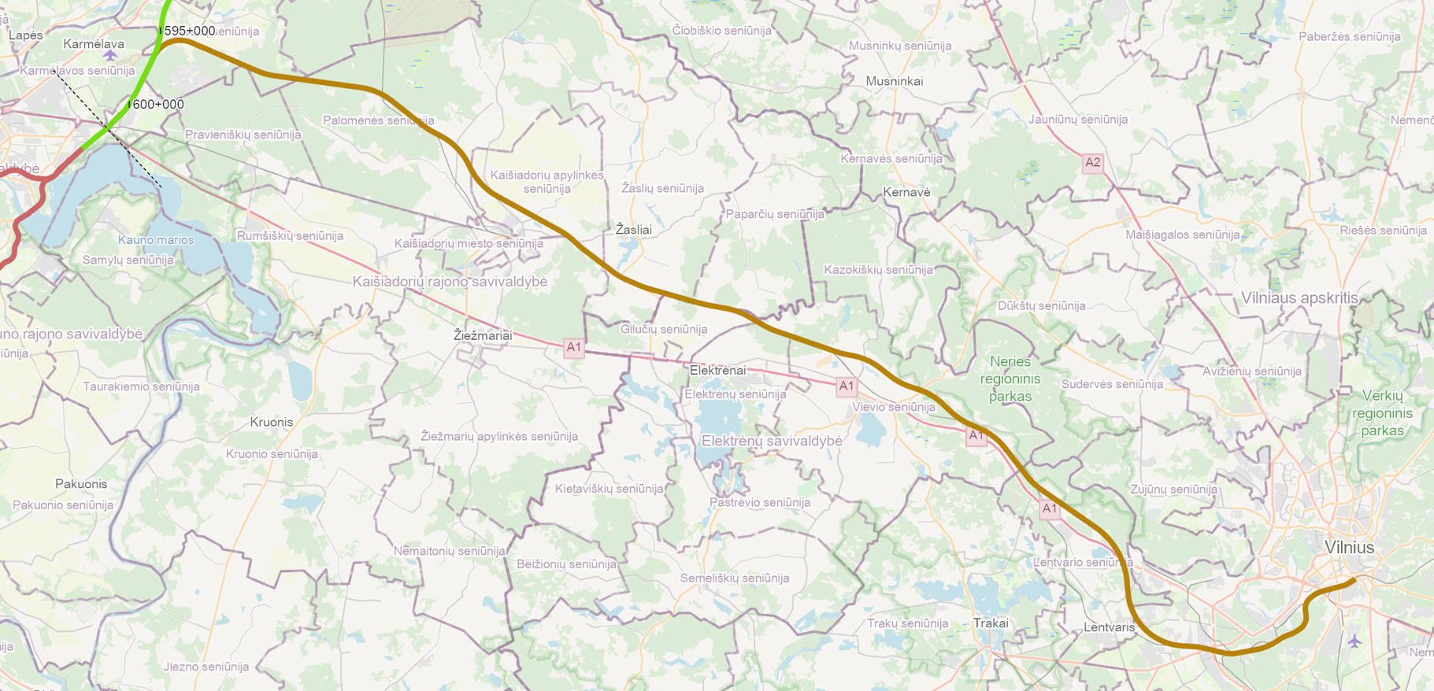  Ch. 0+000  Ch. 86+000  Ch. 21+650
 | Indicative amounts (based on draft EIA studies / spatial planning design) | Vilnius Urban Node (21,650 km) – Kaunas Urban Node (86,000km):  1435 mm gauge railway mainline double track: approx. 64.35 km;  1520 mm gauge existing railway reconstruction: approx. 11 km;  Number of passing loops: 3;  Number of road viaducts: 10;  Number of road tunnels: 1;  Number of railway viaducts: 13;  Number of railway pergolas: 3;  Number of wildlife crossings: 8;  Number of culverts: 15.  Other infrastructure/utilities to be diverted/accommodated along the route:  Affected melioration (land reclamation) grid reconstruction;  Main oil and gas pipeline crossings/reconstructions;  High Voltage 110-330 kV power transmission line crossings;  Other utilities (fibre optics, telecoms, low/mid voltage electricity, other).
 | Required contractor’s personnel
 | Key experts: | Project manager;  Design manager;  1435 mm gauge railway track design expert/engineer;  Structural/bridge design expert/engineer;  Road design expert/engineer;  Geotechnical expert/engineer;  Environment expert/engineer;  Hydrology expert/engineer;  Building Information Modelling (BIM) Manager.
 | Additional experts (non-exhaustive list) | Project Planning Manager;  Local Stakeholder Manager;  Public relations coordinator;  Contract Manager;  Construction planning expert/engineer;  Cost estimation expert;  Design Quality Control engineer;  Power networks designer/engineer;  Railway signalling expert/engineer;  Railway catenary expert/engineer;  Technical translator (from/to Lithuanian-English and English-Lithuanian language);  Geographical information systems (GIS) Expert;  Reliability, Availability, Maintainability, and Safety (RAMS) Engineer;  Natural gas and oil pipeline expert/engineer;  1520 mm gauge railway track design expert/engineer;  1520 mm gauge railway signalling expert/engineer;  Geodesy expert/engineer.
 | Stakeholder management process | Alignment of design process and solutions with related stakeholders and effected parties
 | RB Rail internal regulations (studies) to consider | - Rail Baltica Design Guidelines;  - Building Information Modelling (BIM) Requirements (part of Design Guidelines);  - Rail Baltica Operational Plan;  - Rail Baltica Infrastructure Management Study;  - Visual, architecturalarchitectural, and landscaping guidelines study;  - Mineral materials supply study;  - Related Studies carried out by National Implementing Bodies (freight terminals, maintenance depots, etc.);  - Other.

Design of priority objects shall be shorter. The priority objects shall be defined at the second stage of procurement

