Procurement presentation
Introduction
Lietuvos geležinkelių infrastruktūra, AB has announced a consultation with market. The intention is to receive feedback from the market regarding to the proposed qualification requirements, implementation time, construction splitting into the separate tenders as well as on FIDIC Particular Conditions.
NOTE: all the documents mentioned below are published on Central Public Procurement Information System (hereinafter – the CPP IS) site https://pirkimai.eviesiejipirkimai.lt/ or on https://www.railbaltica.org/.
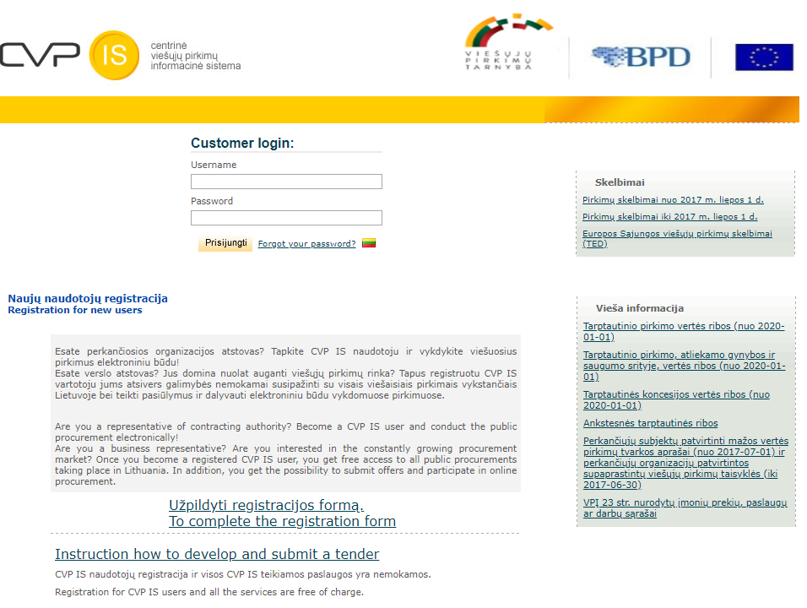

Figure 1Home page of CPP IS and Buyer's registration link (marker red).
Selected procurement method– dynamic purchasing system (DPS).
What is the Dynamic Purchasing System (DPS)?
A DPS is a completely electronic system used by a Contracting Authority (buyer) to purchase commonly used goods, works or services. Unlike a traditional framework, suppliers can apply to join at any time. It is an 'open market' solution designed to provide buyer with access to a pool of pre-qualified suppliers. It can be divided into categories of works, services or goods (referred to as Lots). Suppliers can apply to single or multiple lots within a DPS.
The DPS is a two stage process:
Stage One: Suppliers complete a standard Pre-Qualification (PQ.) All suppliers who meet and pass the exclusion and selection criteria within the PQ must be admitted to the DPS and/or the relevant categories within it. Rejected suppliers are provided with feedback in order to enable them to re-apply at a later date should they wish to do so.
Stage Two: Buyer award individual contracts through the DPS. The buyer invites all potential providers on the DPS (or within a particular DPS category) to participate in a further competition to bid for a specific contract. Suppliers are not obliged to bid.
What ’s the benefit?
From Buyer's perspective:
- Faster and less onerous than a full OJEU tender process - the OJEU and PQ stages have already been undertaken and no further advertisement is necessary.
- After the DPS has been established, authorities can award local contracts. By using the DPS there is no need for an authority to separately advertise its requirement.
- The DPS is based on generic service specifications which authorities can adapt to meet their specific requirements. Award criteria can be formulated more precisely for local contracts.
- Encourages competition - it is easier for local providers to get on to the DPS and join at any time during its period of validity.
- Contracting Authorities can undertake a further competition with all pre-qualified bidders; all qualification documentation is held centrally.
- By following these guidelines Contracting Authorities can ensure that they are adhering to EU procurement legislation.
From Supplier 's perspective:
- Suppliers don 't have to demonstrate suitability and capability every time they wish to compete for a public sector contract.
- Award of individual tenders can be quicker than under some other procedures.
- A DPS remains open to new suppliers throughout the period of the agreement. This enables suppliers who may not be able to meet the selection criteria at the time a DPS is first established to review their processes, finances and capabilities and apply for acceptance onto the DPS at a later stage.
- A supplier who fails the exclusion or selection stage can reapply later if circumstances have changed (for example if it had newly available skills or experience.)
- A supplier may apply for as many categories for which it is suitable.
- Any supplier who meets the selection criteria must be admitted to the DPS.
Setting up of several DPS is planned:
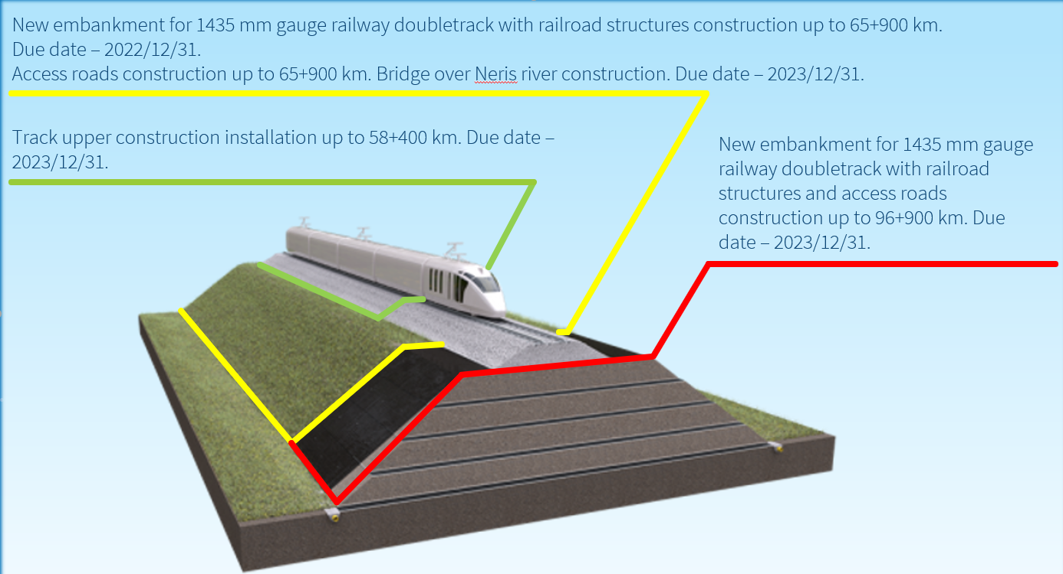
DPS one: New embankment for 249 km/h 1435 mm gauge railway doubletrack with railroad structures and access roads construction (Kaunas - Panevėžys line, from 0+500 km to 96+900 km – approximately 7 individual contracts)
DPS two: Track upper construction installation (section from 0+500 km to 58+400 km).
DPS three:Bridge over Neris river construction (section from 19+510 km to 21+010 km).
Suppliers Pre-Qualification (PQ)
Suppliers complete a standard Pre-Qualification (PQ). All suppliers who meet and pass the exclusion and selection criteria (see annexes*: Kvalifikaciniai reikalavimai sankasos ir statinių statybai; Kvalifikaciniai reikalavimai Neries tilto statybai; Kvalifikaciniai reikalavimai viršutinės kelio konstrukcijos įrengimui) within the PQ to be admitted to the DPS.
Qualification is based on Minimum Set of Requirements for Suppliers** (see Common-procurement-standards-and-guidelines_appendix2.pdf).
Supplier ‘s proposal evaluation
Buyer, respecting past Projects experience and lessons learned, is intending to set the Multi-criteria evaluation (MCE) in order to achieve best service in terms of price/quality balance.
Supplier ‘s proposal components and weights (more in details* - Consulting on MCE.pdf):
- Price – 80%
- Time scheduling – 15%
The Suppliers ability to evaluate process duration dependence to assigned resources will be awarded. Supplier aiming to maximum score must present it‘s exemplary (or successfully implemented Project) time schedule, which should contain sequential workflow tasks with assigned logical dependencies, where task durations are defined by assigned resource productivity which is justified by Supplier. Maximum score – 3 points.
Supplier, committed, to install and use a digital working time on site account system (for employees and heavy machinery) will be awarded with extra 3 points.
- Employee experience (BIM Project management) – 5%
Buyer will award with a maximum score Supplier, who will provide a BIM project specialist, coordinator or manager with experience in BIM Project preparation, implementation or asset management in at least 5 Projects in 10 past years.
Construction Contract
Buyer will sign the Contract with the Winner, based on Red FIDIC book (second edition, 2009). The template of Particular Conditions is added to the consultation documents.
Set out implementation terms:
- New embankment for 249 km/h 1435 mm gauge railway doubletrack with railroad structures and access roads construction (Kaunas – Panevėžys line, see slide „Project deadlines“ for more details) – 2022-12-31;
- Track upper construction installation (section from 0+500 km to 58+400 km) – 2023-12-31;
- Bridge over Neris river construction (section from 19+510 km to 21+010 km) – 2023-12-31.
Scheduled procurement stages***
Date | Event | Comments
June, 2020 | Call for competition on DPS one and DPS two (prequalification).
September, 2020 | Specific contract awarding on DPS one | stage Šveicarija – Žeimiai  stage Žeimiai - Šėta  stage Šėta - Ramygala
October, 2020 | Specific contract awarding on DPS two | bridge over Neris river
November, 2020 | Specific contract awarding on DPS one | stage Palemonas - Šveicarija
December, 2020 | Specific contract awarding on DPS one | stage Ramygala - Berčiūnai

Further tenders to be scheduled.

