Annex No 4: Technical specification

Technical Specification

FOR PROCUREMENT
“The Bridge inspections in Riga”

- Introduction
The Baltic countries Estonia, Latvia and Lithuania have historically been linked to the east-west railway transport axis using the 1520mm gauge railway system. Because of the existing historical and technical constraints, the existing rail system is incompatible with mainland European standards, thus there is a consensus that Estonia, Latvia and Lithuania need to be fully integrated into the wider European rail transport system. Currently there is no efficient 1435 mm railway connection along the Warsaw-Kaunas-Riga-Tallinn axis, i.e. there are missing links or significant bottlenecks. Thus, there are no direct passenger or freight services along the railway axis as the existing infrastructure does not allow for competitive services compared to alternative modes of transport. Thus, the clear majority of the North-South freight is being transported by road transport and the overall accessibility in the region is low.
Rail Baltica is a joint project of three EU Member States – Estonia, Latvia and Lithuania – and concerns the building of a fast conventional double-track 1435 mm gauge electrified and ERTMS equipped mixed use railway line on the route from Tallinn through Pärnu (EE), Riga (LV), Panevėžys (LT), Kaunas (LT) to the Lithuania/Poland state border (including a Kaunas – Vilnius spur) with a design speed of 240km/h. In the longer term, the railway line could potentially be extended to include a fixed link between Helsinki and Tallinn, as well as integrate the railway link to Warsaw and beyond.
In Riga, Rail Baltica railway tracks in the section from Jelgavas street to Zolitūdes street are intended to be located parallel and under the existing 1520 mm tracks. As it is foreseen in the Environmental Impact Assessment, the Rail Baltica railway track will be in a cut&cover tunnel under existing railway track to Jūrmala direction and during the construction, existing traffic will be maintained on at least one 1520mm track.
The beginning of the entrance of the Rail Baltica tunnel in Torņakalns is planned at the planned crossing of Teodora Hermanovska Street, but the exit from the tunnel is planned after the crossing of Liepājas Street.
The Rail Baltica cut&cover tunnel crosses three overpasses - Friča Brīvzemnieka Street, Torņakalna Street and Altonavas Street. Torņakalna Street and Altonavas Street overpasses are included in the National Protected Cultural Monuments List with No. 8069 (http://mantojums.lv/lv/piemineklu-saraksts/8069/) and their conversion or rebuilding is possible only with the permission of the State Heritage Protection Inspectorate (VKPAI).
The conversion of a cultural monument or the replacement of its original parts with new parts is permissible only if this is the only option for preservation of the monument or if the transformation does not result in the decline of the monument's cultural-historical value.
- Objectives of procurement and general description of situation.
The objective of the procurement is to conduct inspections for the substructure (foundations) and superstructure (supports, deck structure) of three (3) road overpasses over the railway in order to evaluate the possibilities to construct a cut&cover tunnel under these overpasses without major changes in the structures themselves. These three overpasses are:
- Friča Brīvzemnieka iela;
- Torņakalna iela;
- Altonavas iela.

Friča Brīvzemnieka iela crossing – plan and side view
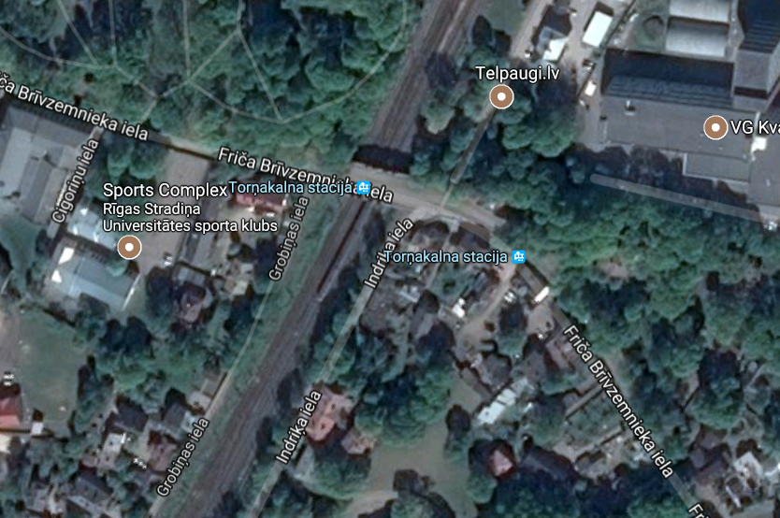

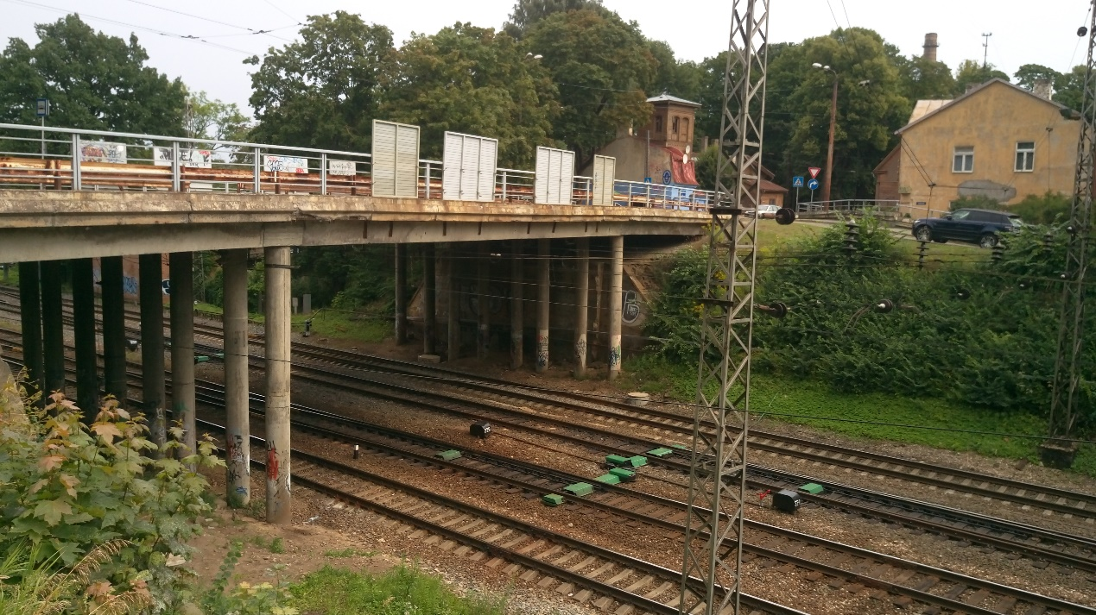

Torņakalna iela crossing – plan and side view
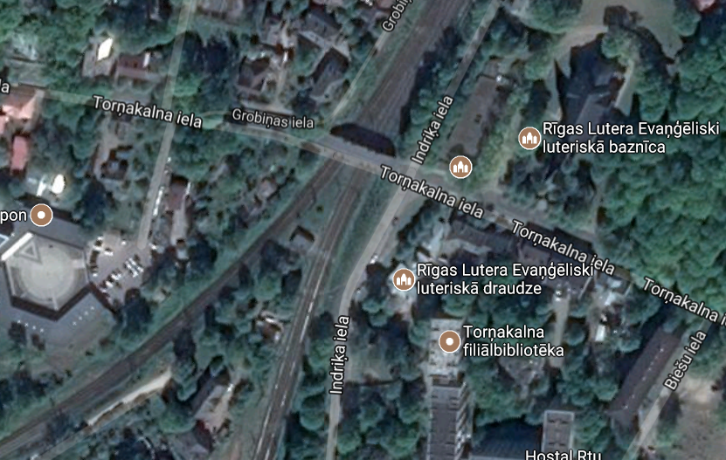
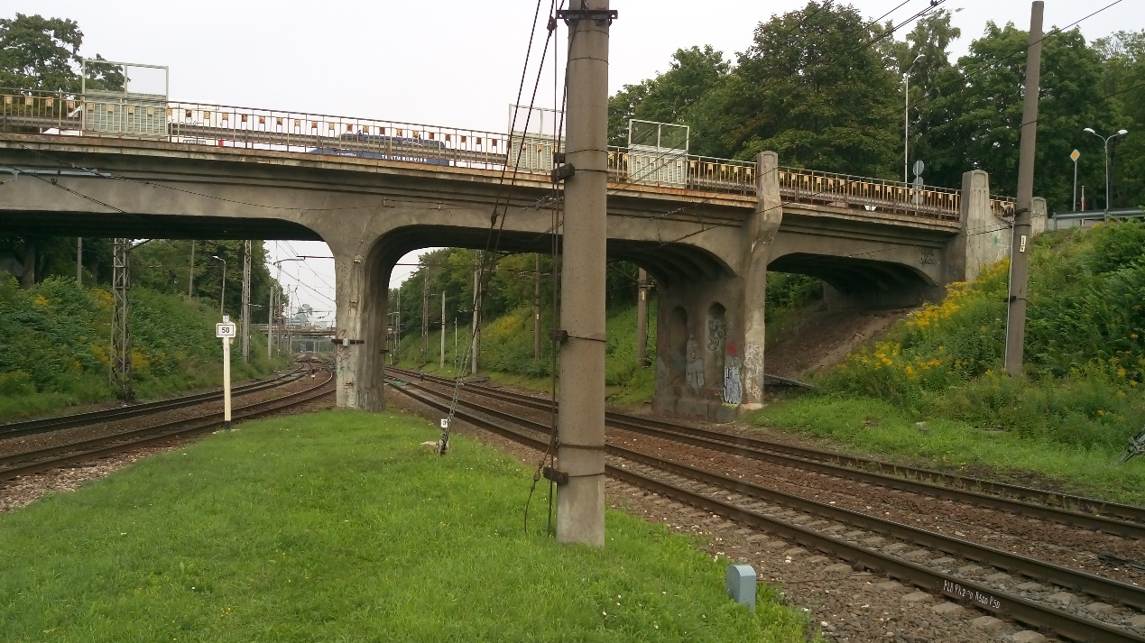

Altonavas iela crossing – plan and side view
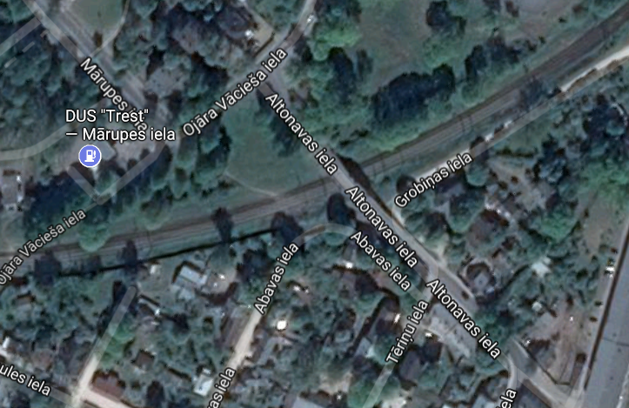
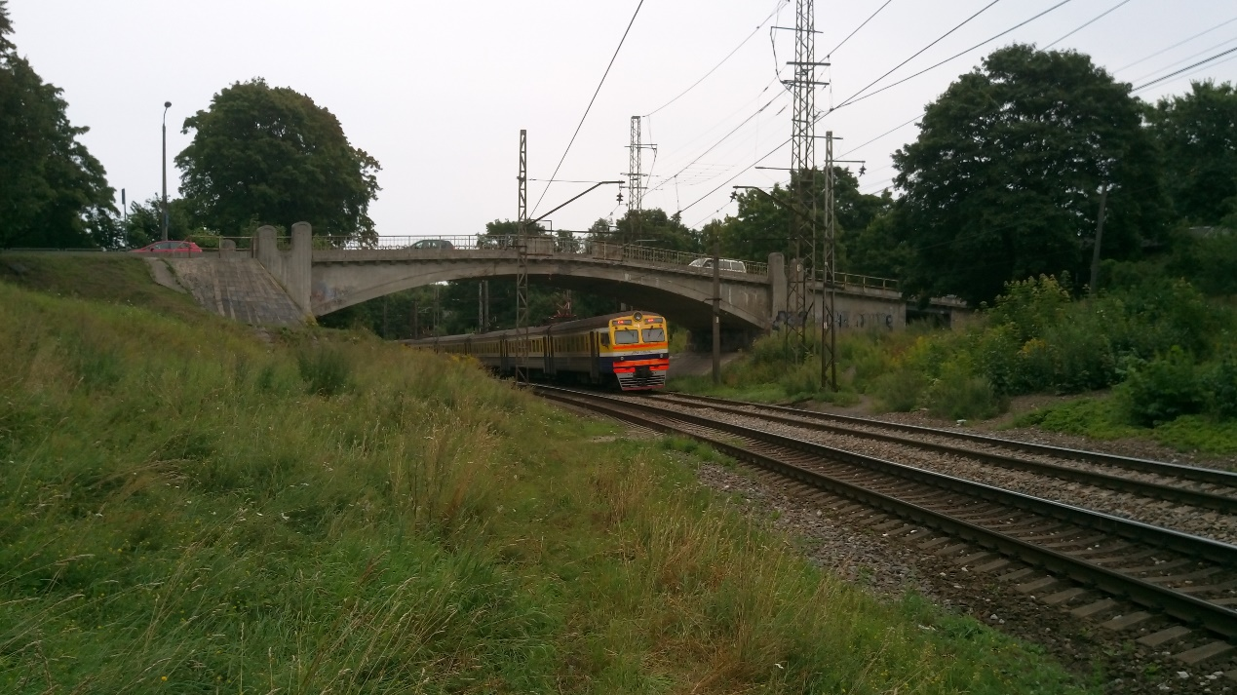

- General Requirements for the Inspections
  - Input documents for the Consulting services
Before any inspection on site, all related inspection reports, archive documents and designs must be examined. The Contractor shall consider the non-exhaustive list of documents provided in this section, which will be handed over to the Contractor at the commencement of the Contract:
    - Environmental Impact Assessment Report for Rail Baltica project in Latvia:
    - Preliminary design and available previous surveys and studies will be handed over to the Contractor;
    - Technical report on Friča Brīvzemnieka street overpass, 2016 (in Latvian);
    - Technical report on Altonava street overpass, 2010 (in Latvian);
    - Technical report on Torņakalna street overpass, 2015 (in Latvian).
  - For the overpasses, the site inspection must investigate and cover the following parts:
    - Substructure:
- Dimensions, location;
- Material and existing condition;
- Possible observable settlement or soil erosion;
- Natural water flows in the area and their impact on the foundations;
Every overpass substructure (foundation) shall be inspected with the proposed means of technology and methodology proposed and ensured by the Contractor.
    - Superstructure:
- Dimensions, location
- Material and existing condition
Overpass superstructure inspection must be carried out according to chapter 6.3 “General inspection” of LVS 190-11:2009.
  - Deliverables
The results of the inspections must be prepared in a report format in English, clearly indicating methodology and technology, and all input information used. Requirements for the deliverables:
Report | Main contents | Submission schedule
Inception Report | Detailed project execution plan  Detailed desk study and site investigation methodology including planned necessary approvals from the authorities to conduct site investigation | CD (date of commecement) + 2 weeks
Interim Report | Analysis of existing archive documents  Approvals for site investigations | CD + 6 weeks
Final Report | Technical inspection report, combining archive information and site investigation data | CD + 10 weeks

  - Inspection approvals and certificates.
It is the responsibility of the Contractor to receive all necessary approvals from all the authorities to do the inspections, for example, from SJSC “Latvijas Dzelzceļš”, Riga City Council (including Traffic Department), State Heritage Protection Inspectorate and any other authorities/institutions involved. All costs for such approvals and any arising supportive activities as required by the above mentioned involved institutions, if any, shall be covered by the Contractor.
For the inspection the Contractor shall ensure certified personal and experts as required by the national law and legislation for such type of the inspection. The Contractor shall have all certificates for the employment of the proposed technology and machinery, if required by the national law and legislation for such type of the inspection on site.
  - Assumptions for the Consulting services timetable.
The scope of the Consultant services has been prepared with the assumption that the open procurement will be carried out and following contract concluded without delays. The commencement of the services planned in January 2018.

- Service contract management
  - Contractor’s obligations
    - For the provision of services the Contractor shall remain fully responsible for the results of its services during and after the provision of services. Any additional expenses arisen due to the correction of the unacceptable results shall be covered solely by the Contractor. On reasonable grounds Contracting authority reserves the right to request the Contractor to correct the results of its services regardless whether it is necessary during the period of service provision or after completion of thereof.
    - In case Contracting authority founds (at any time of procurement process or during the implementation of the Contract for the provision of services) that provided information on education, experience of a Tenderer is found to be false, a Tenderer shall be eliminated from the procurement process or it shall be subject to the termination of contract for the services (whatever is applicable).
    - The Contractor shall ensure necessary effort, means, resources and personnel
required for the successful provision of services.
    - The Contractor shall be responsible for ensuring that its experts included in service contract are available throughout the service provision period.
    - The Contractor must keep records and other supporting documentation (original supporting documents) as evidence that the Contract is performed correctly and the expenses were actually incurred. These must be available for review upon the request of Contracting authority.
    - The Contractor shall include all costs related to office facilities, office expenses, accommodation, transport and work safety of the personnel, insurance, translation and addition expenses in the Contract Price/Fee.
    - The Contractor shall ensure that its team members (experts etc.) involved in service provision are adequately supported and equipped. In particular, the Contractor shall ensure that there is sufficient administrative, secretarial and interpreting provision to enable team members to concentrate on their primary responsibilities. The Contractor must also transfer funds as necessary to support its activities under the Contract, and ensure that his employees are paid regularly and in a timely manner. Costs for administration of service contract and office operation including telecommunication costs shall be included.
    - The Contractor will arrange for formal coordination and decision making on project interventions and establish an adequate internal management structure. At least two meetings with the Contracting authority will be held – the first meeting during on site inspection and the second at the final report presentation. If needed, ad-hoc meetings can be arranged, which may be initiated both by the Contractor, or the Contracting Authority.

  - Provision of services
    - The Contractor must perform the Contract in compliance with its provisions and all legal obligations under applicable EU, international and national law within the set deadlines and to the highest professional, diligence and ethical standards.
    - The Contractor shall carry out the tasks, prepare and provide all documents, reports, minutes of the meetings and any other information material required for the provision of the services.
    - During the implementation of services, the Contractor shall identify possible risks at early stage and propose a mitigation measures in order to successfully deliver services on time.
    - As a part of services, the Contractor shall prepare information material in a fully comprehensive and understandable way, by providing explicit and full source details (initial information, evidences etc.) used for the analysis and provision of services. The deliverables shall include detailed explanation of methods employed that lead to the solutions delivered by the Contractor.
    - Contracting authority shall have no influence on outcome results (reports, summary, advice, decisions etc.) delivered by the Contractor. However, Contractor shall consider Contracting authority’s observations on the initial information used, Contractor shall provide clarifications with the justified argumentation and explain employed analysis methods. The implementation of such observations and clarifications is subject to the approval of the services by Contracting authority.
  - Contractor’s team
    - Only in exceptional cases team members (experts, assistants etc.) included in the Contract can be replaced with the same qualification expert or better by signing an amendment to the Contract. Failing of the Contractor to propose another expert with equivalent or better qualifications might lead to the termination of the Contract.
    - Contracting authority reserves the right to request the Contractor to replace a team member in case of any of the following reasons:
- repeated careless performance of duties;
- incompetence or negligence;
- non-fulfilment of obligations or duties stipulated in the Contract;
- poor knowledge of English language (unsatisfactory presentation, writing skills in English);
- termination of employment relations with the Contractor.

  - Confidentiality, independence and absence of conflict of interest
    - The Contractor is expected to ensure that its contractual and professional obligations in particular with regard to confidentiality, independence and absence of conflict of interests are well understood and upheld throughout and after Services provision.
    - During the provision of services, the Contractor shall provide independent view based on its expertise, education and experience. The Contractor cannot show nor indicate any opinion linked to a particular supplier, company, organisation, institution whatsoever. No representation of any region, country, personal interests shall be shown by the Contractor throughout the service provision period.
  - Checks, audits and investigations
    - Contracting authority reserves the right at any time of implementation of service contract (or afterwards) to carry out investigations related to verification of data provided by the Contractor during the procurement process.
    - Contracting authority may – during the implementation of service contract or afterwards – carry out checks and audits to ascertain compliance with the proper implementation of the assignments (including assessment of deliverables and reports) under this contract and whether the Contractor is meeting its obligations.
    - It may be carried out either directly by their own staff or by any other outside body authorised to do so on their behalf.
    - Under Regulation No 2185/96 and Regulation No 883/2013, the European Anti-Fraud Office may — at any moment during implementation of the Contract or afterwards — carry out on-the-spot checks and inspections, to establish whether there has been fraud, corruption or any other illegal activity under the Contract that affects the EU’s financial interests.
  - Visibility requirements
    - Any reports, brochures, other documents or information connected with Services which the Contractor produces and submits to the Principal, the Beneficiary, any other third person or makes publicly available must include the following:
        - a funding statement stating that Services is the recipient of the funding from the CEF: “Rail Baltic/Rail Baltica is co-financed by the European Union’s Connecting Europe Facility”;
        - (for printed materials) a disclaimer releasing the European Union from any liability in terms of the content of the dissemination materials: "The sole responsibility of this publication lies with the author. The European Union is not responsible for any use that may be made of the information contained therein." This disclaimer in all European Union official languages can be seen at the website: https://ec.europa.eu/inea/connecting-europe-facility/cef-energy/beneficiaries-info-point/publicity-guidelines-logos;
        - the European Union flag.
    - Requirements set in Sections 4.6.1 can be fulfilled by using the following logo:
If the Contractor shall use this logo, the Contractor shall ensure that elements of the logo will not be separated (the logo will be used as one whole unit) and enough free space around the logo shall be ensured;
    - The Contractor is obliged to comply with the latest visibility requirements set by the European Union. For that purpose the Contractor shall follow the changes in the visibility requirements on its own. On the date of conclusion of this Contract the visibility requirements are published on the following website: https://ec.europa.eu/inea/connecting-europe-facility/cef-energy/beneficiaries-info-point/publicity-guidelines-logos.
  - Miscellaneous
    - Communication under service contract (e.g. information, requests, submissions, formal notifications, etc.) must be carried out in English;
    - Contracting authority is deemed as the administrative instance and will be responsible for making the principal decisions. The contracting authority will be responsible for settling the operative and professional issues.
    - Contracting authority shall fully and irrevocably acquire the ownership of the results provided by the Contractor throughout the implementation of service contract, including copyright and other intellectual or industrial property rights, and all technological solutions and information contained therein, produced in performance of service contract.

