Annex No 2: Technical specification

- RB Rail AS background information and the project’s objectives:
RB Rail AS is a joint venture between the three Baltic States established in October 2014, RB Rail AS has three equal shareholders: SIA Eiropas dzelzceļa līnijas in Latvia, UAB Rail Baltica statyba in Lithuania, and OU Rail Baltic Estonia in Estonia.
The main business of the Company is the design, construction and marketing (including branding) of the Rail Baltica railway – a new fast, conventional double-track, electrified railway line with a maximum design speed of 240 km/h for passengers and 120 km/h for freight, utilising European standard-gauge rails (1435 mm) on the route from Tallinn through Pärnu-Rīga-Panevezys-Kaunas to the Lithuanian-Polish border, with a Vilnius-Kaunas connection.
Total estimated Rail Baltica Global Project^{[1]} costs are around 5,8 billion euros, largely financed by EU financial instruments, i.e., the Connecting Europe Facility (CEF). This is the largest infrastructure project in the Baltic States to date.
Rail Baltica is a geopolitically, ideologically and commercially diverse project with a multifaceted stakeholder structure. Therefore, common understanding of the purpose and values of the project, as well as the ability to demonstrate a unified approach and opinions are essential for the successful implementation of the entire project. Moreover, the Rail Baltica Global Project is certain to come under close scrutiny from the public, governments and European institutions, because of its scale and financing sources (EU and the three Baltic States). Rail Baltica, as all large-scale infrastructure objects, is a strategic long-term investment project and its communication strategy should be developed and implemented accordingly.
- Rail Baltica Communication by the official implementers
There are few implementing bodies of Rail Baltica in Estonia, Latvia and Lithuania (more info: http://www.railbaltica.org/project-implementers/). Thus, there are several official communication actors for the project in three countries. To ensure the coordinated communication for the project where several project implementers are active in Rail Baltica communication in three Baltic States, the concept One Baltic Voice (OBV) is introduced and it is based on the distribution of competences. The Contracting Scheme of Rail Baltica signed in 2016 defines procurement roles of the joint venture RB RAIL AS, beneficiaries and national implementing bodies by dividing procurement into three categories – RB RAIL AS procurement, consolidate procurement, and supervised national procurement. The Grant Agreement lists the activities that are in the competence of RB RAIL AS, beneficiaries and national implementing bodies. In result, the communication tasks and the themes communicated should be divided in accordance with procurement roles and the responsibilities divided by the Grant Agreement and the Contracting Scheme. However, the Grant Agreement has also determined that all of the parties involved are responsible for project awareness and public support. RB RAIL AS has a coordinators’ role for the communication activities for the Rail Baltica Global Project and provides an umbrella communications strategy for the project implementation by all communication actors in all three countries.
Responsibilities of RB RAIl AS:
- Creates and delivers content;
- Content and experience exchange/coordination/facilitation centre;
- Supports Implementing Bodies.
Responsibilities of the Beneficiaries and Implementing Bodies:
- Adapt and apply OBV content, communication guidelines, plans and topics;
- Create local content using OBV messages.
Additional information about the project on the official site of the Rail Baltica: http://www.railbaltica.org/

- Services to be provided:
1) services related to the development of Rail Baltica Communications Strategy,
2) public relations services:
- Strategic consultations and briefings,
- Media relations;
- Marketing of the project to future clients (general public; freight and passenger operators);
- Stakeholder management;
- Event organization (including the Rail Baltica Global Forum – content, invitations, registration process, agenda, publicity, etc.);
- Communication research;
- Campaign organization;
- Project public information preparation;
- Critical issue management.

- Set targets:
- To raise awareness of the Rail Baltica project and its various economic, technical, financial aspects and future impact on countries – participants within the stakeholders.
- To build a positive reputation for the project by creating a powerful brand story communicated in one voice in all three Baltic countries.
- To gain support from opinion leaders and industry experts for the project implementation and management team.
- To build trust and credibility for the Rail Baltica management team primarily among policy and decision makers as well as within the media.
- To manage communication in a manner that minimizes the appearance of negative opinions in the public space.
- To prepare for crisis communication.

- Stakeholder Groups:
5.1. Primary stakeholder groups:
- National/regional policy makers
- European institutions
- Regulatory bodies
- Experts/Academia
- Trade and Industry organisations
- Potential and existing business partners/suppliers
- Industrial consumers (Freight, Travel, Logistics)
- Environmental and Social NGOs
- Future passengers/ users
- Media
5.2. Secondary stakeholder groups
- Permit-issuing authorities
- Communities/Municipalities
- Land owners
- Tasks for the contractual period:
- Development of the Rail Baltica Global Project’s Communication strategy (for the period 2020 - 2026 with annual revisions), outlining:
  - communication objectives,
  - key messages
  - stakeholder groups,
  - potential communication risks,
  - communication channels,
  - communication methods (for example, media, 3rd party endorsements, conference),
  - communication approach for each stakeholder group,
  - communication budget
The geographical scope: Estonia, Latvia, Lithuania, some activities for Poland/Finland as essential stakeholders in the project, and general global project's communication.
- Development and implementation of communication action plan in Latvia, Estonia, Lithuania – key communication activities, budget, and resources allocated to delivery of the strategy.
- Content development: textual, visual, event (on average three activities per month – press release, discussion, media or stakeholder event);
- Marketing communication – development of content for printed materials if needed to promote the project within stakeholder groups;
- Development of presentation content;
- Campaign development and implementation;
- Event organisation
- Content creation for project website;
- Media relations;
- Media (print, internet, social, TV, radio) information flow analysis to identify upcoming or development of existing critical issues, advise on recommended actions;
- Regular meetings with the client on the communication planning and strategy preparation (according to Point 8.2)
- Crisis communication plan development, advisory and implementation;
- Reporting.

- Key communication principles:
Transparency and openness
- Transparency and openness are two of the key communication principles. These principles will help address Baltic and European society and institutions, thereby increasing trust within the stakeholders for fair and open practice, implemented throughout the project, from media to EU decision makers, getting support for further key decisions.
Communications harmonization – One Baltic Voice
- Communications harmonization will ensure that Rail Baltica speaks with a consistent voice. Continuously sending out a consistent message is crucial.
- Issue variations in each Baltic country as well as the changing stages of project development must be taken into account and reflected in communication.

- Cooperation Model between RB RAIL AS and Supplier
RB RAIL AS is looking to have efficient cooperation model with the Supplier. Since the project implies cross-border operations and activities in multiple countries, the clear understanding on how the daily cooperation should be carried out must be ensured to reach the best results.
The supplier should provide the public relations services in Estonia, Latvia and Lithuania, and in general global communications.
Two possible models for Supplier can be used:
- A group of suppliers, representing Estonia, Latvia and Lithuania, who have formed a partnership for this particular open competition and have sufficient experts who comply with the selection criteria for tenderers of this competition
- A supplier with in-house communications experts based in Estonia, Latvia, Lithuania who complies with the selection criteria for tenderers of this competition
8.1. Coordination:
As regards model A, a group of suppliers must decide who will be the main coordinator (legal entity) in the cooperation process with RB RAIL AS. The main coordinator’s task would be to network between the group members and to act as a single point of contact with RB RAIL AS (i.e., provides the common opinion, campaign proposal, action plan, moderates between the suppliers etc.). The main coordinator should act as a national communications expert/ executor in one country and should ensure the project's global communication. While other two partners would act as experts for their countries and ensure public relation services execution in their respective countries. The main coordinator undertakes responsibility for reporting and invoicing on behalf of the group (See Model 1).
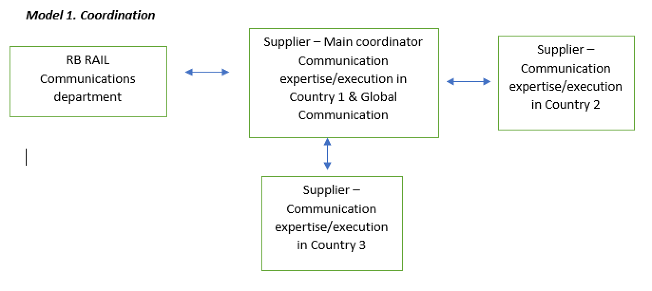
8.2. Planning and Execution:
For daily communication, alignment and coordination RB RAIL AS will expect in both models that supplier(s) assign one main contact person. For the Communication planning and execution purposes, one representative from all three countries are assigned for participation at the monthly, quarterly or any on demand meetings (in presence or in correspondence) with the RB RAIL Communications’ department. There will be weekly briefings/ communication planning meetings with representatives of the main coordinator only.
During monthly meetings all experts together from three countries will plan monthly Communications’ Activity plan for the Baltic and global communication, will set the execution plan (timing, responsible party for delivery) and targets to be reached in certain communication period. In addition, all representatives of three countries, wold be asked to participate in the campaign creation to come up with one vision for global and pan-Baltic communication. Each representative will have the same role and significance in this planning and execution process. Also, it is expected that team representing all three countries will participate in communication strategy formulation.
In order to ensure Once Baltic Voice, a representative from each country will be invited to participate at the quarterly Rail Baltica Communications Network meetings in presence or using skype meeting function.
In addition, if there is need to organise dedicated meeting on specific activities for one country only, the planning and execution is directly organised with the communications expert(s) from the respective country with action briefing to main coordinator.
- Deliverables:
A) Final Report of the Rail Baltica Global Project Communications Strategy 2020 - 2026 till July 31, 2019
B) Public relations (Communications) services to implement the Rail Baltica Global Project Communications Strategies
- Defects Date – 2 (two) weeks after final report submission of the Rail Baltica Global Project Communications Strategy 2020 – 2026
- Term of the contract - 36 (thirty six) months.
[1] The Baltic part of the Rail Baltica project is referred to as the Rail Baltica Global Project.

