ANNEX NO 1: APPLICATION

2017.___._______
No____________
APPLICATION FOR PARTICIPATION IN THE PROCUREMENT
“TECHNICAL EXPERTISE OF THE CUT – AND COVER – RAILWAY TUNNEL”, No RBR 2017/32
Tenderer [name of the Tenderer or members of the partnership], reg. No. [registration No of the Tenderer or members of the partnership], represented by [name, last name and position of the representative of the Tenderer], by submitting this application:
- Confirms participation in the procurement “Technical expertise of the cut – and cover railway tunnel” No RBR 2017/32.
- Proposes to provide technical expertise services of the cut – and - cover railway tunnel in accordance with the Technical specification and this Proposal for the following Contract price (excluding VAT):
_______________ euro, ____cents

- Confirms that the Regulation is clear and understandable, that it does not have any objections and complaints and that in the case of granting the right to enter into a Contract it shall fulfil all conditions of the Regulation as well as enter into a procurement Contract in accordance with the draft Contract enclosed with the Regulation.
- Guarantees that all information and documents provided are true.
- declares that, for the purposes of qualifying for the procurement, we rely on the capabilities of the following entities:
No | Name, registration number and registered address of the entity | Capabilities on which the Tenderer relies
1.
2.
3.

- declares that during the execution of the Contract we will have sub-contractors as stated below and confirm that the list is complete:
No | Name of the sub-contractor | Sub-contracted tasks
 |  | Description of the sub-contracted task | Amount, EUR (without VAT) | % from the proposed price
I | Total amount of the sub-contracted tasks is equal to or exceeds 10% from the proposed contract price
1
2
n+1
Total:
II | Total amount of the sub-contracted tasks is smaller than 10% from the proposed contract price
1
2
n+1
Total:
Total (I+II)

We meet the criteria of (please mark):
a small medium other
sized enterprise as defined in the Article 2 of the Commission Recommendation of 6 May 2003 concerning the definition of micro, small and medium-sized enterprise;

______________________________ ______________________________
Date: [date of signing] Name: [name of the representative of the Tenderer and position]

ANNEX NO 2: EXPERT’S APPLICATION

EXPERT’S APPLICATION
TO PARTICIPATE IN THE PROCUREMENT Id . No RBR 2017/32

“TECHNICAL EXPERTISE OF THE CUT – AND – COVER RAILWAY TUNNEL”
FOR THE SERVICE LINE

____________________________
Title of the Service line

____________________________
Country of experience

Name of Expert:
Education
Obtained degree
Contact information (phone and e-mail)

ANNEX NO 3: EXPERT’S PROFESSIONAL EXPERIENCE
No | ___________________________________________ _______________________  Expert’s role in team Name, Surname
1. | Education  (Educational institution) |  | Period of studies  (month/year – month/year) | Obtained degree (-s)
1.1.
…
 | Professional experience:
2. | Employer, Project, Contracting authority | Period of employment or participation in the project (month/year – month/year) | Description of the responsibilities according to contract to comply with respective criteria in Section 7.3. for respective expert. | Description of project (implementation period, scope, value of the project*, total eligible costs*, countries involved in project, etc. )  Contact information for references
2.1.
2.2.
n+1

I confirm that I have consented that my candidature is proposed in the open competition “Technical expoertise of the cut – and – cover railway tunnel”, No RBR 2017/32. I confirm that in case the Tenderer [name of the tenderer or members of the partnership] will conclude the contract as the result of the open competition, I will participate in the execution of the contract.
______________________________
Date: [date of signing]
Name: [name of the expert]

Annex No 4: Technical specification

Technical Specification

FOR PROCUREMENT
Technical expertise of the cut-and-cover railway tunnel

- General
  - Introduction
The Baltic countries Estonia, Latvia and Lithuania have historically been linked to the East-West railway transport axis using the 1520mm gauge railway system. The existing rail system is incompatible with mainland European standards, thus there is a consensus that Estonia, Latvia and Lithuania need to be fully integrated into the wider European rail transport system. Currently there is no efficient 1435 mm railway connection along the Warsaw-Kaunas-Riga-Tallinn axis, i.e. there are missing links or significant bottlenecks. There are no direct passenger or freight services along the railway and the majority of the North-South freight is being transported by road transport.
Rail Baltica is already designed to become a part of the EU TEN-T North Sea – Baltic Core Network Corridor, which links Europe’s largest ports of Rotterdam, Hamburg and Antwerp – through the Netherlands, Belgium, Germany and Poland – with the three Baltic States, further connecting to Finland via the Gulf of Finland short sea shipping connections with a future fixed link possibility between Tallinn and Helsinki.
Further northbound extension of this corridor shall pave the way for future connectivity also with the emerging Arctic corridor. Furthermore, the North Sea – Baltic Corridor crosses with the Baltic-Adriatic Corridor in Warsaw, paving the way for new supply chain development between the Baltic and Adriatic seas, connecting the Baltics with the hitherto inadequately accessible Southern European markets. In a similar fashion, Rail Baltica shall strengthen the synergies between North-South and West-East freight flows, creating new transshipment and logistics development opportunities along the Europe and Asia overland trade routes. The new Rail Baltica infrastructure would, therefore, not only put the Baltics firmly on the European rail logistics map, but also create massive opportunities for value creation along this infrastructure with such secondary economic benefits as commercial property development, revitalization of dilapidated urban areas, private spin-off investment, new business formation, technology transfer and innovation, tourism development and other catalytic effects. Rail Baltica aims to promote these effects from the early stages of the Global Project, learning from the key global success stories and benchmarks in this regard.
The contracting authority RB Rail AS (RBR) was established by the Republics of Estonia, Latvia and Lithuania, via state-owned holding companies, to coordinate the development and construction of the fast-conventional standard gauge railway line on the North Sea – Baltic TEN-T Core Network Corridor (Rail Baltica II) linking three Baltic states with Poland and the rest of the EU. The main technical parameters shall correspond to traffic code P2-F1 as per INF TSI (Commission Regulation 1299/2014/EU) and shall have the following main technical parameters:
- double track, design speed on the main track 250 km/h, design speed on side tracks minimum 100 km/h;
- axle load 25 t;
- distance between track centres at least 4.50 m on the main tracks;
- distance between two sided passing loops approximately 50 km and crossovers approximately 25 km;
- all pedestrian, road and 1520 mm rail crossings only as above or below grade crossings (segregated grade crossings), fencing and noise barriers where needed;
- ERTMS Level 2 with possible update to the newest version;
- communications system GSM-R with a view to accommodate the new generation railway communications standard;
- electrification 2x25 kV AC;
- length of freight trains 740m, but for spatial planning and track geometry design a length of 1050m shall be used;
- length of passenger trains 200m, but for spatial planning and track geometry design a length of 400m shall be used;
- height of passenger platforms 550mm;
- maintenance road, where necessary, shall be on one side of the tracks with gravel 3.5m wide
The shareholders structure of RBR is presented in Figure 1.
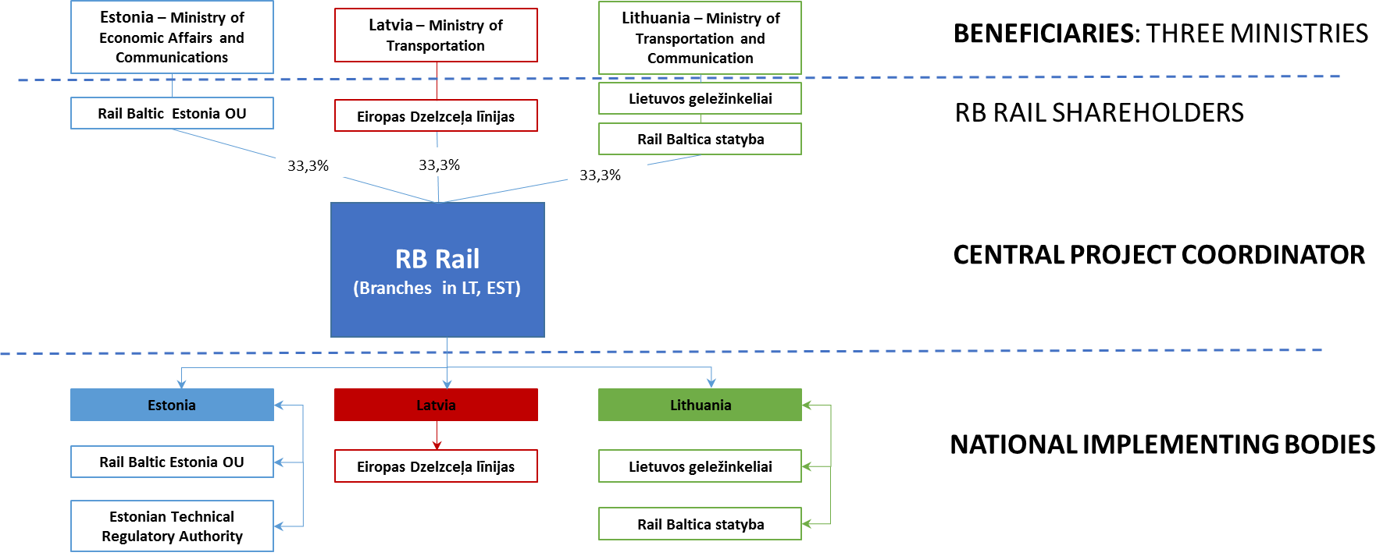
RBR together with governments of Estonia, Latvia and Lithuania (represented by the ministries in charge of transport policy) have applied for the CEF co-financing in 2015, 2016 and 2017 (three applications in total). The first two applications were successful and INEA grants are available to support the Global Project expenses with up to 85% of co-financing in amount of 633 mln EUR. A further application is currently under evaluation.
Rail Baltica is a joint project of three EU Member States – Estonia, Latvia and Lithuania – and concerns the building of a fast conventional double track 1435 mm gauge electrified railway line on the route from Tallinn through Pärnu (EE), Riga (LV), Panevėžys (LT), Kaunas (LT) to the Lithuania/Poland state border (including connection Kaunas - Vilnius). In the longer term, the railway line could potentially be extended to include a fixed link between Helsinki and Tallinn, as well as integrate the railway link to Warsaw and beyond.
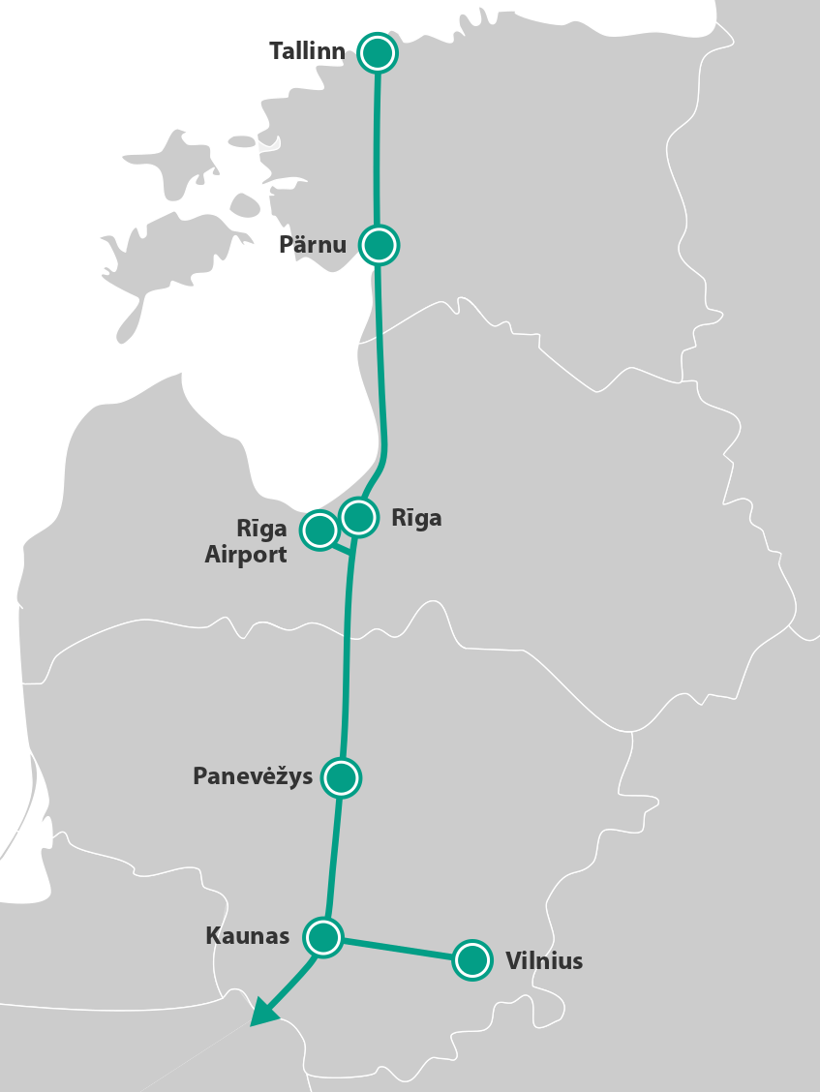
Figure 2. Rail Baltica railway line route through Estonia, Latvia and Lithuania.
The expected core outcome of the Global Rail Baltica Project is a European gauge (1435mm) double-track railway line of almost 900 km in length meant for both passenger and freight transport and the required additional infrastructure (to ensure full operability of the railway). It will be interoperable with the TEN-T Network in the rest of Europe and competitive in terms of quality with other modes of transport in the region. The indicative timeline and phasing of the project implementation can be found here: http://www.railbaltica.org/about-rail-baltica/project-timeline/.
Further information is available in http://www.railbaltica.org/
  - Procurement for the technical expertise of the cut-and-cover railway tunnel.
As a result of Preliminary design, and available previous surveys and studies, as well as taking into account difficult construction and operational conditions (as explained further) it was decided to carry out the additional technical expertise of the cut-and-cover railway tunnel for the Rail Baltica section in Riga from Riga Railway central station to Riga Airport.
This technical expertise is a critical part of the Consolidated preliminary technical desing (CPTD) report, which is a basic prerequisite for Detailed technical design (DTD) procurement technical specification and provides input data for designers.
  - Abbreviations and terms
CAPEX | Capital expenditures
Contract | signed agreement between Contracting authority and Contractor to prepare Expertise through the provision of Consulting services defined in this agreement.
Contractor | service provider awarded with a Contract to conduct Expertise.
Consulting services | all necessary activities being and to be implemented by the Contractor as required in the Contract.
EU | European Union.
Expertise | result of expert services, provided by the Contractor, necessary to continue detailed investigations as discovered by Consulting services and to elaborate technical specifications of detailed technical design.
National studies | detailed engineering and feasibility studies on implementation of Rail Baltica project in each of the three Baltic states, covering EIA, preliminary design, feasibility studies, spatial planning and similar activities.
OPEX | Operating expenses
Programme | Expertise programme, proposed by the Contractor and approved by the Contracting authority, shall include graphical representation of main Expertise milestones and deadlines of deliverables as required in Terms of reference.
Rail Baltica project | future railway line preventing missing links in the European railway network and improving the existing network infrastructure on the route Warsaw – Kaunas – Riga – Tallinn – Helsinki, and ensuring full railway interoperability and better railway usage indicators in passenger and cargo traffic. The project ensures Baltic State integration into the EU railway area. The project is the part of the TEN-T core network North Sea-Baltic corridor.
Rail Baltica railway | new fast conventional double track electrified railway line with the maximum design speed of 240 km/h and European standard gauge (1435 mm) on the route from Tallinn through Pärnu (EE), Riga (LV), Panevėžys (LT), Kaunas (LT) to Lithuanian – Polish border, with the connection of Kaunas – Vilnius.
Railway infrastructure | has the same meaning as an identical term in the Directive 2012/34/EU of the European Parliament and of the Council of 21 November 2012 establishing a single European railway area (recast), as well as it includes freight and passenger terminals and infrastructure and rolling stock maintenance facilities and the ground underneath them and the airspace above them to the extent that the national legislation permits the ownership of the ground and the airspace.
Railway infrastructure | has the same meaning as an identical term in the Directive 2012/34/EU of the European Parliament and of the Council of 21 November 2012 establishing a single European railway area (recast), as well as it includes freight and passenger terminals and infrastructure and rolling stock maintenance facilities and the ground underneath them and the airspace above them to the extent that the national legislation permits the ownership of the ground and the airspace
RB Rail AS,  Contracting authority | a joint venture established by the Republics of Estonia (EE), Latvia (LV) and Lithuania (LT) to coordinate the development and construction of the fast-conventional standard gauge railway line on the North Sea – Baltic TEN-T Core Network Corridor linking three Baltic states with Poland and the rest of the EU.
RAMS | Reliability, Availability, Maintainability and Safety
Technical specification | this document forming a part of Service procurement regulations and Contract following the procurement procedures;
TSI | Technical Specifications for Interoperability.
WP | Work package, a defined part of Contractor’s activities, to be carried out under the Contract’s requirements.
- technical expertise framework
  - Scope of the Expertise
    - Introduction of the cut-and-cover tunnel.
The Preliminary design with the related studies and Environmental Impact Assessment (EIA) have been carried out in 2014 – 2016, as a result Rail Baltica railway route in Latvia approved by Cabinet of Ministers. The cut-and-cover railway tunnel is part of the Rail Baltica section in Riga city, which is located between Riga Railway central station to Riga Airport.
In Riga, Rail Baltica railway tracks in the section from Jelgavas street to Zolitūdes street are intended to be located parallel and under the existing 1520 mm tracks. As it is foreseen in the Preliminary design and Environmental Impact Assessment, the Rail Baltica railway track will be in a cut-and-cover tunnel under existing railway track to Jūrmala direction and during the construction, existing traffic will be maintained on at least one 1520mm track. The beginning of the entrance of the Rail Baltica tunnel in Torņakalns is planned at the planned crossing of Teodora Hermanovska Street, but the exit from the tunnel is planned after the crossing of Liepājas Street.

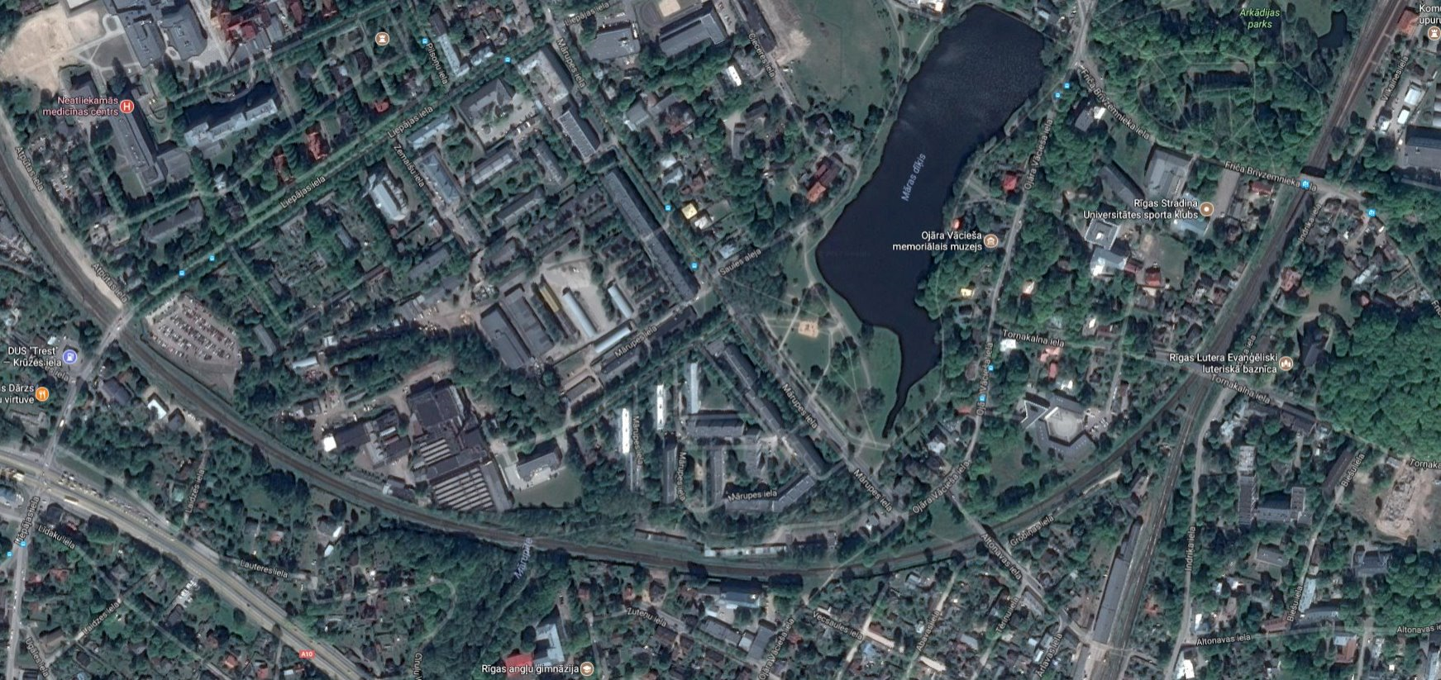
Figure 3. Schematic alignment of tunnel.
The Rail Baltica cut-and-cover tunnel crosses three overpasses - Friča Brīvzemnieka Street, Torņakalna Street and Altonavas Street. Torņakalna Street and Altonavas Street overpasses are included in the National Protected Cultural Monuments List and their conversion or rebuilding is possible only with the permission of the State Heritage Protection Inspectorate.
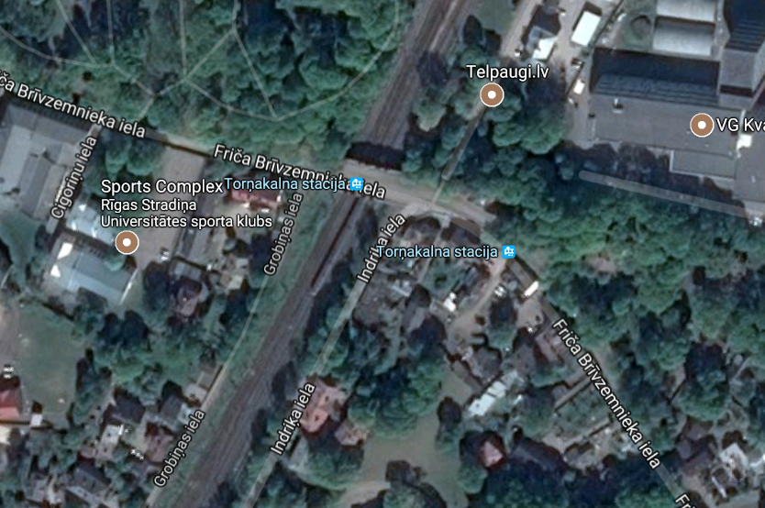
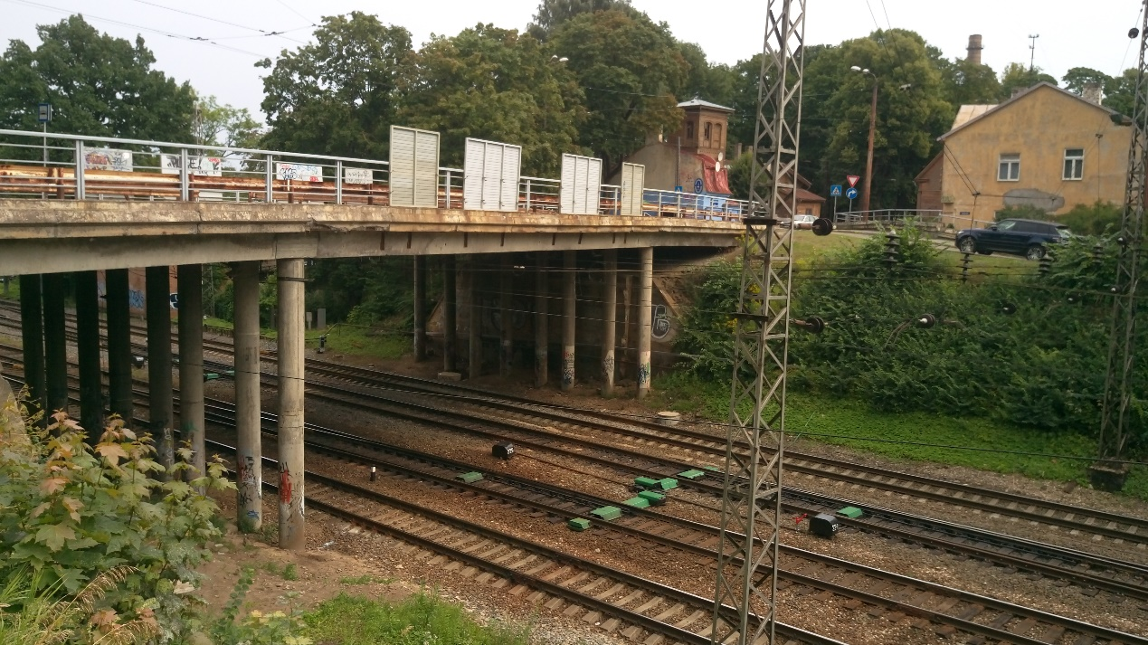
Figure 4. Friča Brīvzemnieka street crossing – plan and side view
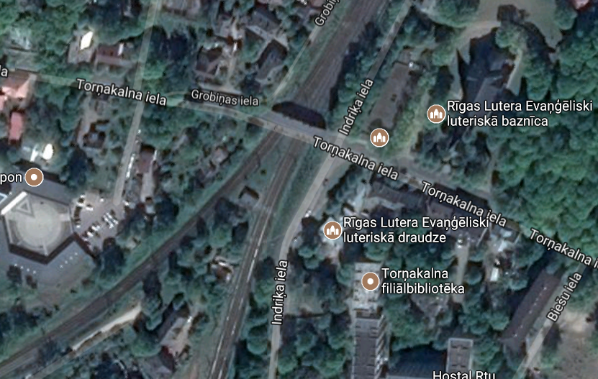
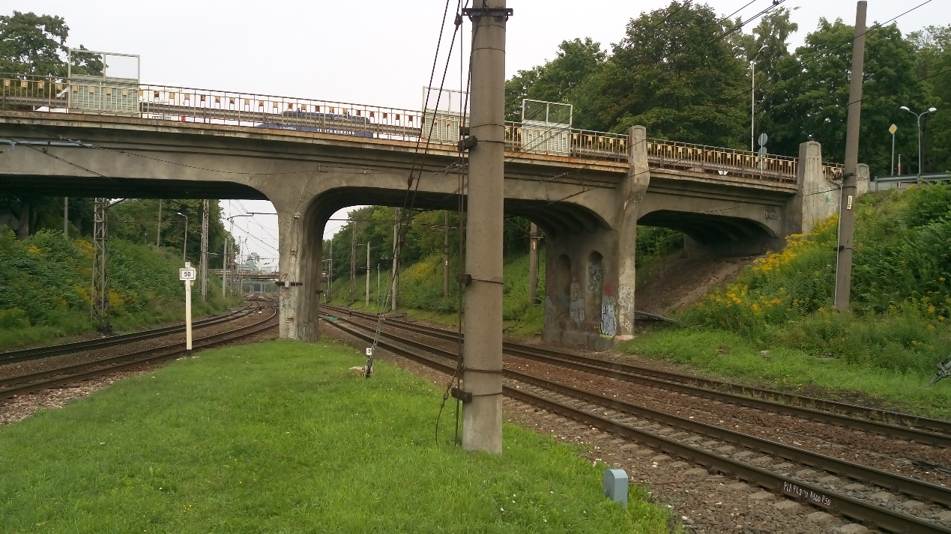
Figure 5. Torņakalna street crossing – plan and side view

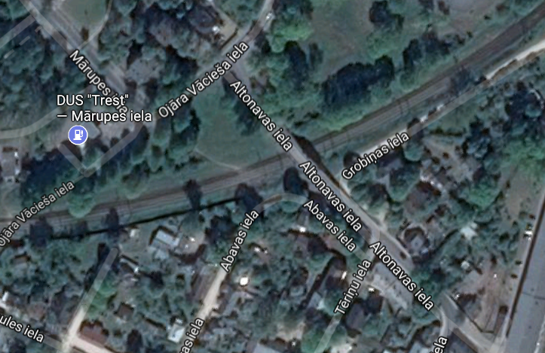
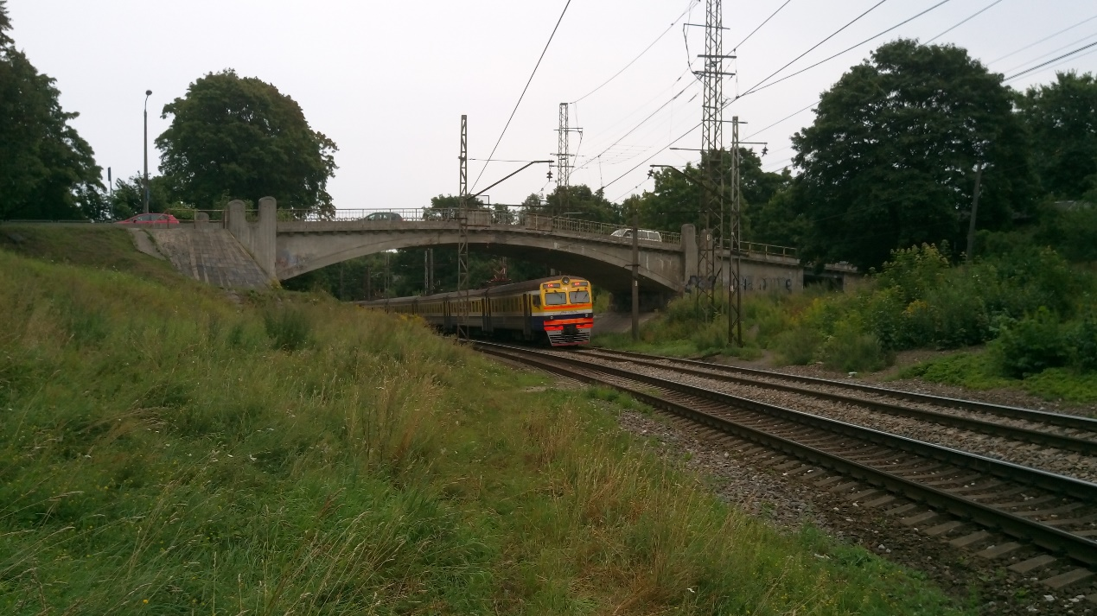
Figure 6. Altonavas street crossing – plan and side view

    - Key technical parameters of the cut-and-cover tunnel (as per preliminary design):
- Electrified high speed railway line, double track 1435mm;
- Total length: 1,81 km;
- Length of the tunnel entrance: approx. 350 m;
- Length of the tunnel exit: approx. 350 m;
- Mārupītes river (~ 10 m wide) crossing underneath of the tunnel;
- Equiped with emergency exits, ventilation, lightening, cable troughs, radio coverage equipment for a fire emergency and maintenance needs etc.;
- Tunnel is located in the existing 1520 mm railway right of way. The existing electrified 1520mm railway double track (including 25 t axle load freight trains) will operate above the tunnel in the entire length;
- Three road overpasses in Friča Brīvzemnieka street, Torņakalna street and Altonavas street crosess both railways (1435mm in tunnel and 1520mm above the tunnel). The cut-and-cover tunnel shall be constructed as far as possible without major changes to the structures of the overpasses themselves.
  - Objectives
    - Main objective is to evaluate preliminary solutions of the tunnel from the viewpoint of safe and efficient railway operations, tunnel constructability and the LCC persectives. The consultant has to provide the answer that the cut-and-cover railway tunnel technical solution is safe to operate both by Rail Baltica and existing railways (1520mm gauge) above the tunnel.
    - The consultation services have to provide the additional technical expertise of the cut-and-cover railway tunnel for the Rail Baltica in order to define next priority steps to be carried out, including the all necessary investigations, to secure precise definition and description of the technical specification for the detailed technical design, thus ensuring safe detailed technical design of the tunnel and construction input.
    - The Contractor through analysing the best practices, applying best knowledge and experience, deploying smart technologies and innovations shall deliver the highest quality of expert services, which will become an integral part of Rail Baltica railway and will ensure safe, interoperable, efficient and cost-effective railway operations.
    - The cut-and-cover railway tunnel as a long-term investment needs to be thoroughly analysed by evaluating latest technologies and costs associated (both CAPEX and OPEX) in order to avoid possible over-investments, as well as under-investments. Thus the railway line operational and maintenance aspects have to be considered from the point of view of effectiveness to increase railway value for money.
  - Input documents for the Consulting services
The Contractor shall consider the non-exhaustive list of documents provided in this section, which will be handed over to the Contractor at the commencement of the Contract:
    - Rail Baltica studies for Latvia: Environmental Impact Assessment.
    - Preliminary design and available previous surveys and studies will be handed over to the Contractor.
    - Riga city strategic development and spatial (territorial) plans, which relates to the Expertise.
  - Assumptions for the Consulting services timetable:
    - The scope of the Consultant services have been prepared with the assumption that the open procurement will be carried out and following contract concluded without delays. The commencement of the services planned in January 2018.
  - Risks and assumptions of the tunnel area:
- High groundwater level;
- Possible old underground rivers, hidden river areas;
- Possible undisclosed archeological discoveries and cultural heritage monuments and structures;
- In the right-of-way of the existing railway;
- Several intersections with existing city street network;
- Proximity to several living houses.
  - Deliverables and deadlines
    - The Contractor shall provide Consulting services in English and submit the following deliverables:
Deliverables/Reports | Submission deadline | No. of copies | Description of deliverable  (as per section 3. below) | Approval through Contracting Authority
Inception Report | 4 weeks after CD | 2 hard copies,  1 soft copy | Analysis of the input documentation, and findings of the first on site inspection. (WP1).  Updated recommendations, methodology and program, for the further steps and investigations (WP2). | 1 week after reception
Draft Final Report | 6 weeks after CD | 2 hard copies,  1 soft copy | Assessment report of the proposed tunnel solutions, proposals for change in solutions, change in alignement (tunnel geometry and cross-section), if applicable. Proposals shall be supported with the necessary benchmarking analysis. (WP3)  Preparation of specific construction requirements for detailed technical design (WP4)  Value engineering for the Contracting Authority’s purpose. (WP5)  Suggested terms and conditions to be included in the design and construction contracts. (WP6) | 1 week after reception
Final Report | 8 weeks after CD | 3 hard copies,  1 soft copy | Final report have to be submitted taking into account the Contracting Authority’s comments.  Minimum content:  - Short summary of WP1 and WP2.  - Final version consisting of WP3; WP4; WP5; and WP6.  The outcomes of the final report have to be presented in presentation for the Contracting Authority’s management. | 1 week after reception
    - The deadline for the provision of the Consulting services is 8 weeks from the commencement date (CD).

- Description of expertise
The Expertise is organized in accordance with the following work packages (WP):
  - WP1: Input documentation and on site inspection;
WP1 shall include analysis of the input documentation, taking into account Contractor’s findings of the first on site inspection and discussion with the Contracting authority. Analysis of the input document is to reflect Contractor’s understanding of Expertise’s objectives, scope and further milestones. During the analysis the Contractor shall identify the proposals regarding cut-and-cover tunnel technology, methodology, options, further steps and investigation to achieve the objectives. Risks shall be identified at early stage of Expertise implementation and whenever possible.
  - WP2: Updated program and further investigations;
The Contractor shall prepare Expertise programme for its services to be provided. Expertise programme shall include representation of main Expertise’s milestones and deadlines of deliverables as required in Technical specification. The purpose of Expertise programme is to show the further milestones, to present all necessary subjects and to provide high quality professional Consulting services on time.
Recommendations of the Contractor shall be aligned with currently implemented interstate Rail Baltica project agreements, as well as existing national and Riga city strategic development and spatial (territorial) plans. Riga city spatial and strategy plans shall be incorporated in the analysis.
The Contractor shall also provide status and results of the Expertise to the Contracting authority in a form of presentation summarizing major findings and further activities. At the request of the Contracting authority the Contractor shall present presentation, with the necessary clarifications and explanations to the questions which might raise.
  - WP3: Proposed technical solutions for tunnel;
In this WP the Expert shall assess the preliminary solutions of the tunnel from the viewpoint of safe and efficient railway operations, tunnel constructability and the LCC persectives. The consultant has to provide the answer that the cut-and-cover railway tunnel technical solution is safe to operate both by Rail Baltica and the existing railways (1520mm gauge) above the tunnel, and under what conditions. The Expert shall assess the proposed tunnel solutions, proposals for change in solutions, change in alignement (tunnel geometry and cross-section), if applicable. The Expert shall define the best proposals for detalisation in the following WP and in parallel communicate it to the Contracting authority.
The Contractor shall support Expertise implementation with the necessary benchmarking analysis and the best practical examples of similar cut-and-cover tunnel in terms of key technical parameters and similar operational conditions with two different railways. Examples shall describe the best contractors for the cut-and-cover tunnel construction world wide during the past ten years.
  - WP4: Specific construction requirements for detailed technical design;
Preparation of specific construction requirements for detailed technical design that has to be respected by the tunnel designers. The Exepert shall define all critical technical terms and parameters, including principal alignment and layouts, dimensions, ventilation with the equipment, emergency exits with the lightening, cable troughs (including cable distribution solutions), location of the radio coverage equipment (ampliefier) for a fire emergency needs and also maintenance communication needs, etc. Proposals shall take into account proposed construction technology options and sequence, risk mitigation measures as well as recommended climate conditions for such works. The small river path underneath of the tunnel shall be specifically described with the cross section drawings and proper staging/sequence during construction process.
Requirements shall include reference to all standards related to the tunnel construction. Definition of the minimum requirements and coefficients as required by the standards shall be part of the critical requirements.
As part of the technical solution the Contractor shall propose respective maintenance management strategy for the entire tunnel.
For the safe operational purposes the Contractor shall propose software based detection tools or intelligent in advance warning system with the technical specifications for the cut-and-cover tunnel condition monitoring, measurement and preventive maintenance.
The Contractor shall implement risk analysis for all topics to be covered within the scope of the Expertise and provide mitigation measures to avoid or minimise those risks, covering also main materials’ production and supply, technology changes, innovative technology solutions, etc.
The Contractor shall propose all further needed studies and investigations if required.
The Contractor shall ensure that all building Eurocodes, EN standards, TSIs and key RAMS aspects are met during Expertise implementation, including through analyzing the geotechnical, hydrogeological conditions as well as assessing stability calculations and definitions of stability principles.
  - WP5: Value engineering;
Value engineering for the Contracting Authority’s purpose shall be described in the WP5. The railway tunnel investments needs to be thoroughly analysed by evaluating latest technologies and costs associated (both CAPEX and OPEX) in order to avoid possible over-investments, as well as under-investments. The Contractor shall conduct value engineering for the technical solutions and deployment strategies by estimating also CAPEX and OPEX as well as life-cycle costs.
  - WP6: Suggested contractual terms and conditions to be included in the design and construction contracts;
The Experise shall also recomend the contractual terms and conditions, (including liability and insurance conditions) to be included in the design and construction contracts, which are typicaly used for such tunnels worldwide.

The information on the size of the Candidate is used solely for statistical purposes and are not in any way whatsoever used in the evaluation of the Candidates and their Requests to participate.
Available here - http://eur-lex.europa.eu/legal-content/EN/TXT/?uri=uriserv:OJ.L_.2003.124.01.0036.01.ENG&toc=OJ:L:2003:124:TOC
Separate expert’s application for every country of every Service line shall be prepared.

